DAILY ASSESSMENT FORMAT

|  |  |  |  |
| --- | --- | --- | --- |
| Date: | 23-07- 2020 | Name: | Persis P |
| Course: | workshop | USN: | 4AL17EC069 |
| Topic: | How to develop Pythonic coding rather than Python coding | Semester & Section: | 6 & B |
| GitHub  Repository: |  |  |  |

SESSION DETAILS

Session images

Report:

Python

scripts can put the system into different states, set configurations, and test all sorts of real

-

world use cases.

Python

can also be used to receive

embedded

system data that can be stored for

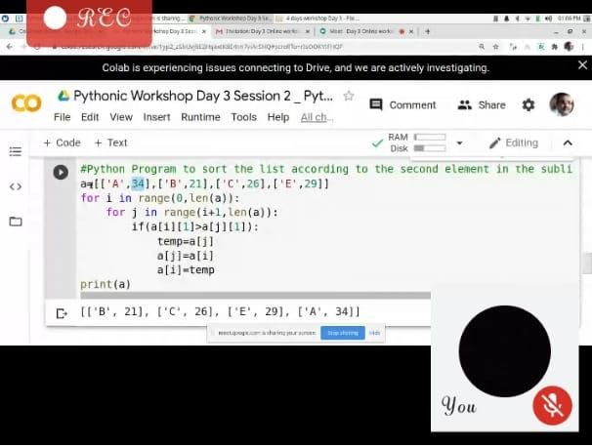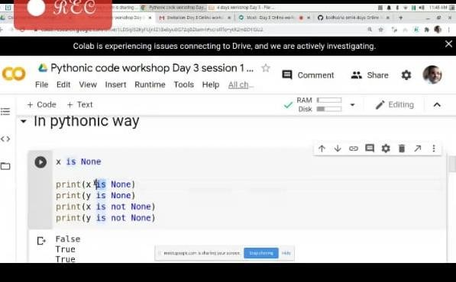

analysis. Programmers can then use Python to develop parameters and other methods of analyzing that data.

A tuple is a collection of objects which ordered and immutable. Tuples are sequences, just like lists. The differences between tuples and lists are, the tuples cannot be changed unlike lists and tuples use parentheses, whereas lists use square brackets.

Tuples are immutable which means you cannot update or change the values of tuple elements.

You are able to take portions of existing tuples to create new tuples

The most basic data structure in Python is the sequence. Each element of a sequence is assigned a number - its position or index. The first index is zero, the second index is one, and so forth.

Python has six built-in types of sequences, but the most common ones are lists and tuples, which we would see in this tutorial.

There are certain things you can do with all sequence types. These operations include indexing, slicing, adding, multiplying, and checking for membership. In addition, Python has built-in functions for finding the length of a sequence and for finding its largest and smallest elements.